# Dataset Description

## Dataset Overview

**Organization Name:** LEUMIT

**Number of Records:** 1100

**Data Domain:** Gynecology

## Cohort Characterization

**Number of Distinct Patients:** 1090

**Medical Indications Covered:** visits to a gynecologist

**Minimum Text Length (total terms):** 7

**Average Text Length (total terms):** 117.13

**Maximum Text Length (total terms):** 503

## Dates

Date Range of Records: 2020-01-02 to 2024-12-31

## Data Source

**Original Data Source:** Visits.

**Hebrew Count: 957**

**English Count: 44**

**Mixed Count: 99**

**Hebrew Ratio: 87%**

**English Ratio: 4%**

**Mixed Ratio: 9%**

## Distribution of Text Lengths

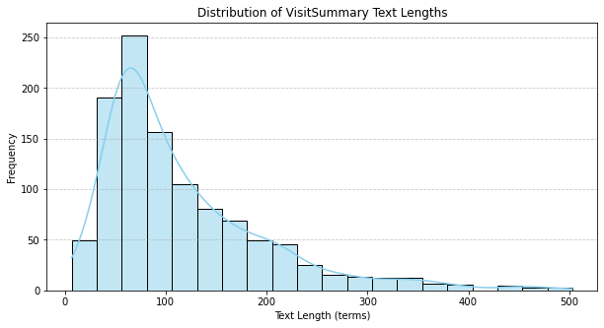

## Distribution of Record Dates

